Autonomous Underwater Surveillance Drone (AUSD)

- Title of Invention
Autonomous Underwater Surveillance Drone with Integrated Sonar and AI-based Threat Detection for Naval Security.

Field of the Invention
The current invention comprises various underwater vehicles; however, it is more related to the autonomous underwater vehicles (AUVs) that are common in the marine sector for carrying out activities like surveillance, monitoring, and threat detection. Autonomous underwater vehicles carry out all the activities stated above using sonar technology (which helps them locate objects while they are under water), artificial intelligence (which helps them detect threats), and real-time communication technology (which improves safety and situational awareness in coastal and naval areas).
The intention behind this innovation is to meet the demands of the need for an underwater surveillance system that can function independently amid dynamic changes in ocean environments. Such types of circumstances are why Autonomous Underwater Vehicles (AUV) units were invented. Present-day underwater surveillance systems use manual labor followed by data analysis. Thus, conventional underwater surveillance systems cannot react and cope with dynamic threats under the water surface. In order to overcome such challenges, this innovation uses a collective subsystem (sonar sensing units, embedded processors, AI algorithms, and communication interfaces) working as a single integrated system known as AUV; hence, AUV operations, either autonomous or networked.
The sonar device consists of a passive and active sonar array used for detecting objects due to their acoustic properties when time stamps for sound waves are acquired. There is a digital signal processor mounted in this apparatus that processes all incoming signals in real-time; meanwhile, a machine learning algorithm will analyze those signals and categorize objects depending on features obtained from them. Such an algorithm will enable distinguishing between marine objects (coral reefs and marine wildlife) and security threats (like submarines and drones) to a country and help detect these threats to autonomous underwater vehicles.
Besides the real-time communication feature, the AUV can send surveillance data and alarms through encrypted lines. The use of radio waves is involved, although the mode of transmission will vary depending on the type of surveillance being carried out. This means that it is possible for the AUV to activate countermeasures and even alert patrolling units. It is also possible for several AUVs to operate in tandem with each other and exchange information.
The autonomous underwater vehicles have the capability to undertake many security tasks in the ocean like harbor protection, border surveillance, protection of underwater assets, among others. The sensors based on sonars, analysis by artificial intelligence, and autonomous navigation makes the system very reliable in providing services for observation in dangerous waters. Therefore, ideal places for deployment of autonomous underwater vehicles include places where the ships navigate autonomously.
The invention developed at this time will solve previous monitoring issues through an offering of a complete, upgraded, intelligent and self-sufficient device capable of providing national defence, as well as marine situational awareness capabilities. Therefore, developing unmanned underwater platforms is necessary.

Background of the Invention
Coastal areas—including naval bases, offshore oil rigs, and the boundaries of national waters—are becoming more vulnerable to a number of underwater threats, such as unauthorized divers, submersible sabotage, underwater mines, and unmonitored or hostile autonomous surface vessels. Each of these underwater threats poses a substantial national security, commercial shipping, offshore oil and gas production, and critical infrastructure risk. Historically, typical underwater surveillance techniques have relied upon the use of stationary sonar arrays, periodic human divers checking for threats with visual inspection, or manned submersibles conducting patrols under the water. All of these methods have severely limited spatial coverage, are expensive to operate, and either scan infrequently or do not provide for continuous monitoring.
Conventional underwater surveillance systems are also hindered by their dependence on human operators to detect, identify, and act on threats—characterized by detection delays and diminished performance due to a rapidly evolving underwater environment. In addition, the underwater environment is naturally difficult to detect threats within due to the dynamic topography of the sea bottom, natural turbidity in the water, and poor acoustic properties of the water; all of which impede the ability of stationary sensors to perform their intended purpose.

Significant progress in autonomous underwater vehicles (AUVs) has opened up many possibilities for the monitoring of our underwater environment; however, at the current time most existing systems have some limitations whether they be too focused on oceanographic research alone, too little autonomy or not having a wide enough range of integrated capabilities so that they include advanced threat detection systems, intelligent decision-making capabilities and ongoing surveillance of their area of operation. In particular, none of the current AUVs being used deploy silent propulsion methods, provide real-time sonar mapping, use artificial intelligence to identify threats, develop autonomous path plans based on SLAM technology or provide secure means for the transmission of data from under the sea to above surface control systems throughout the world.
Consequently there is an urgent and unmet need for a comprehensive autonomous underwater surveillance capability that can operate independently in both shallow and deep water, provide mapping for those areas where no underwater topography exists and facilitate live information transfer between above-surface control systems and under-water AUVs. The current invention described herein provides such an undersea autonomous surveillance capability through the development of an Autonomous Underwater Surveillance Drone (AUSD) that utilizes an integrated multi-layer sonar suite, smart algorithms to detect anomalous activity, electrically powered stealth propulsion systems and secure communications relay channels to transfer data captured during the surveillance operation in real-time.
The new technology provides an advanced upgrade to previous methods of surveillance within underwater environments; namely, it delivers a self-sufficient underwater monitoring system enhanced with AI technology that operates autonomously without the need for human intervention. Additionally, the system incorporates mobility, intelligence, and communications on one platform to improve the situational awareness of those overseeing coastal areas while simultaneously reducing the reliance on personnel to operate the systems; thus allowing for immediate recognition and reporting of any threats that may exist within the underwater environment.

Summary of the Invention
An Autonomous Underwater Surveillance Drone (AUSD) system for continued use in ocean surveillance and threat detection has been developed. A multi-layered sonar system, a machine-learning-based anomaly classifier, a quiet (electric) motor, and a means to transmit data to the surface through a tethered or wireless surface buoy, make up the AUSD.

This invention is intended to be fully autonomous, allowing the underwater drone to either follow a predetermined route while monitoring a particular maritime area or to modify its route based on environmental conditions. The AUSD utilizes SLAM technology to provide a means for accurate underwater navigation without the need for GPS by utilizing sonar returns from the surrounding environment along with inertial measurements to create a map of the underwater environment and determine its location in real time.

In addition, the present invention includes an onboard Artificial Intelligence (AI) module that can process visual data and acoustic data to identify, classify and prioritize any anomalies or possible underwater threats that have been detected. For example, unauthorized submersible vessels or divers incursion and underwater mines or any other suspicious objects. The classification of detected items will be used to evaluate the threat and determine the severity of the threat. Depending on the severity of the threat, autonomous alerts can be generated and/or action taken by either evasion from the threat, close inspection of the threat, or coordination with other nearby drones via a swarm behavior.

The AUSD also has an integrated docking and recharging station that allows the AUSD to autonomously return to that station to dock and recharge without human assistance. A surface communications relay (tethered or buoy-based) is also provided to transmit the sensor data and AI classified report from AUSD to a centralized control station or naval command center without any intervention from a human operator.

The AUSD system's modular architecture lends itself to scalability, also allows the units to be deployed in a swarm formation, and easily integrates into existing naval surveillance systems. The AUSD represents a highly capable, intelligent, and energy-efficient underwater surveillance system that can be utilized for national security, coastal defense, and protection of critical marine infrastructure.

Objectives of the Invention
This invention is aimed at developing an autonomous underwater surveillance drone (AUSD) with a ability to operate fully on its own, 24/7, in high-risk maritime areas (i.e., coastal borders, harbors, offshore platforms and strategically important submarine areas). This system will reduce the need for human intervention, maximize the amount of time it can operate, and provide an intelligent and adaptive response to constantly changing threats underwater.
Another objective of this invention is to provide a multi-layered sonar system that can detect objects in real time, map out the environment and assist the drone in navigating through the environment. The sonar system will have both active and passive components so it can detect a variety of objects and obstacles in the water (i.e., submerged vessels, divers, mines, uncharted underwater terrain). These sonar systems will also be used in enabling the drone to use Simultaneous Localization and Mapping (SLAM) to navigate autonomously without the use of external guidance systems such as GPS which don't provide any value underwater.
The invention's additional key objectives include the integration of onboard artificial intelligence (AI) algorithms utilized to identify anomalies. The purpose of these AI algorithms will be to process acoustic and or visual data in order to identify and classify objects detected using learned models, as well as to identify benign object types (e.g., marine animals, geographical features) vs. potentially threatening object types (e.g., underwater divers, unmanned aerial vehicles, sunken explosives). The classification module will provide the autonomous operational capability to produce a prioritized assessment of threats in real-time and thereby allow for appropriate reaction to those threats using prescribed behaviors. A further objective of the invention is to permit secure real-time communication of data between the underwater drone and either surface based control centers or mobile naval assets. The communication will be facilitated through the use of a communication relay system -- typically utilizing a surface buoy or tethered interface capability -- that will provide encrypted telemetry, surveillance, and threat alert data to be transmitted without loss of stealth and with maximum operational efficiency. Finally, the invention seeks to establish means of providing energy autonomy through the implementation of an underwater docking and recharging station. This docking and recharging system will allow the AUSD to autonomously return to a designated docking station, recharge its power supply, and resume patrolling without requiring human assistance -- therefore providing unlimited mission duration and unbroken surveillance cycles.
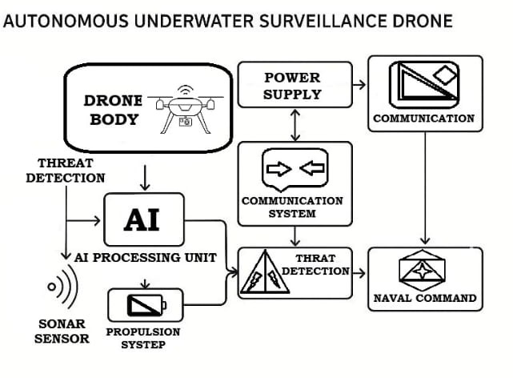

Detailed Description of the Invention
System Components

- Body and Engine
- Composite structure withstands pressure
- Electricized silent propulsion with two thrust-vectored propellers to create forward propulsion.
- Internal ballast tanks allow for control of buoyancy and depth.
- Sonar
- Multi-beam imaging sonar used to create high-resolution 3D maps.
- Diver detection sonar (DDS) actively scans for threats, such as divers and mines.
- Side-scan sonar uses sonar images to map the seafloor and classify the terrain and objects on it.
- Passive sonar array detects the sound signature of equipment and people.
- AI-Based Detection
- Ability to detect an anomaly in real time (diver/mines/objects, etc.)
- Utilizes pre-trained CNN models on sonar imagery.
- Creates adaptive paths using Simultaneous Localization And Mapping (SLAM) integrated with AI.
- Communications and Relay
- Acoustic modem for communication under the water.
- Surface buoy relay system with RF/satellite uplink.
- Secure/Encrypted packets for data transmission.
- Power and Docking
- Lithium polymer battery packs
- Underwater charging dock using magnetic induction interface
- Auto-returning feature once battery level drops below 20%
- Control and Navigational Instruments
- Onboard navigation system that combines SLAM and Inertial (motion) sensors
- GPS via triangulation using surface buoy
- Dynamic mission programming and re-configurable zones

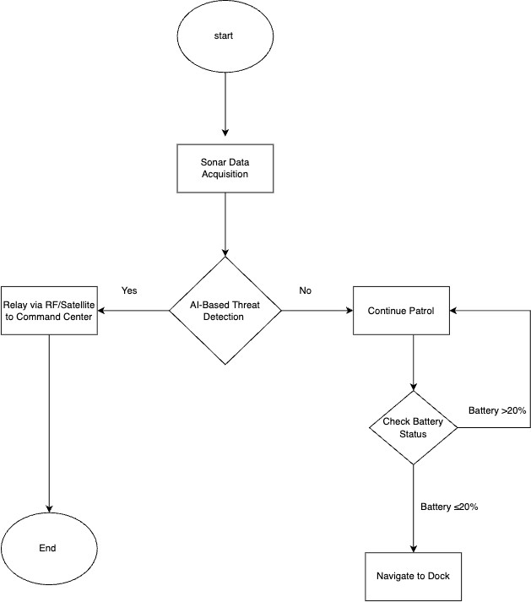

Technical Advantages and Novelty
- Integrated Threat Detection System
The inventive step consists of an improved method of using sonar to create a sonar-based environment map of an area, along with artificial intelligence (AI), to be used onboard the Autonomous Underwater Surveillance Drone (AUSD) to detect and classify anomalies in that environment in real-time, rather than simply collecting data on each mission for post-mission evaluation, as is done with conventional Autonomous Underwater Vehicles (AUVs). The AUSD is not designed to passively collect data about possible underwater threats. Rather, it actively searches for and identifies suspect objects or targets, using a fusion of both active and passive sonar imaging as well as machine learning algorithms. In this way, AUSD can perform the real-time assessment of all objects in the vicinity of the drone, distinguishing between normal or expected marine activities and any suspicious objects or targets, and initiate some sort of response to any potential threats without relying on human commands or oversight.
- Real-Time Communication and Data Uplink
The AUSD provides a real-time communications capability via a low-latency, secure communications system that allows for the real-time transfer of surveillance data, alerts, and AUSD System Diagnostics from the AUSD to surface command stations or mobile naval units in real-time. AUSD does not require the use of post-mission retrieval of data, such as is normally required of traditional AUVs. Instead, the AUSD uses a surface buoy or tether to the surface to create a secure encrypted communications channel for real-time uplinks to provide surface command stations and other support units with continuous situational awareness and command feedback. This is particularly important for time-critical defence and security operations in high-risk maritime areas.

- Autonomous Docking & Charging System
Another way this new invention is unique from similar products on the market, is by having an underwater docking station that allows the AUSD to automatically recharge, update software, or download data while submerged without needing any intervention from people on the surface or needing to retrieve it manually (for example, by using a large boat).

- Modular Sonar Stack Design
A major aspect of this invention is its modular design for sonar systems which allows easy customization of sonar arrays for different missions. This would enable configurations that could include high-resolution imaging sonar used for harbour defence, long range acoustic sensors for border surveillance, and/or specialized inspection sonar used for infrastructure, such as pipelines, undersea cables and platforms, because of this high level of flexibility this device will be applicable to many different missions providing it with high levels of versatility and scalability in relation to all types of military, industrial and research uses.

Industrial Application
The invention can be deployed in:
- Naval harbors and dockyards.
- Offshore oil installations.
- Maritime border patrols.
- Sensitive underwater infrastructure monitoring.

Embodiments of the Invention
Embodiment 1:
A small sized AUV (dimensions: 1.2 meters long and 25 centimeters in diameter) using a sonar system with three levels to patrol a harbor area autonomously detects that there is a human diver approaching the harbor property line and flags them as a potential threat to the AI system. The AUV then transmits an alert via the buoy to the surface control station in real-time.
Embodiment 2:
A group of several AUSD units are able to work together using mesh communications while underwater so that they can mark the path of a pipeline on the ocean floor and also locate an unknown object made of metal that is near, but not attached to, the pipeline. Each AUSD unit is also able to classify the object as well as record geospatial information related to its location.

Embodiment 3:
The AUSD is able to dock at an underwater station to recharge its batteries without requiring any assistance from humans and after 1 hour and 30 minutes it will continue its patrol route without any further assistance from humans.

Claims
- An autonomous underwater drone network used for surveillance that includes:
- A propulsion module to allow for silent travel underwater.
- A sonar system that contains multi-beam imaging, a diver detection system, and side-scan sonar.
- An artificial intelligence-based anomaly detection processor that provides real-time identification of threats.
- An acoustic communications system that is linked to a relay location buoy on the surface of the water.
- A power system with the ability to automatically dock and recharge.
- The sonar system from claim 1 can provide concurrent 3D imaging, passive listening, and active threat mapping in real-time.
- The artificial intelligence processor of claim 1 has been trained to classify threat types based on sonar data by utilizing deep learning models.
- The drone network from claim 1 incorporates SLAM-based navigation with adaptive mission programming.
- The relay location buoy of claim 1 can transmit through RF or satellite uplinks and will float at a specific anchor point based on the GPS coordinates.
- An example of a docking station that uses magnetic charging is an underwater dock with permanent fixed installation on the ocean floor.
- Multiple drones are capable of flying together in a coordinated formation using an undersea mesh acoustic network to work together as a swarm of cooperating vehicles.
- The control software allows the drone's navigation system and scanning protocols to adaptively change depending on real-time threats and/or environmental influences with the development of advanced mission planning software.
- A number of different drones will be operating in a coordinated swarm to cooperatively patrol, detect, and observe anomalies over a very large geographic area using an undersea acoustic mesh network.
- The complete system allows offline operation with the ability to update cloud-based AI models with the surface buoy's uplink on a periodic basis.

Abstract

With increasing concern for maritime security, the development of intelligent autonomous underwater systems is critical. The Autonomous Underwater Surveillance Drone (AUSD; an advanced AUV) is a system designed to provide (pervasive and continuous) surveillance and threat detection in both coastal and offshore waters. The AUSD combines advanced sonar detection systems with artificial intelligence (AI)-assisted threats classification, autonomous navigation systems, and secure communication into a modular platform suitable for defense, critical infrastructure protection, and environmental monitoring.
The AUSD employs multiple sonar systems such as multibeam imaging sonars for three-dimensional (3D) mapping of terrain, side-scan sonars for wide-swath search, diver detection sonars (DDS) for the detection of human threats, and passive sonar arrays for acoustic analysis. All of these sonar systems are interfaced into a single onboard AI (based) on deep learning model, which allows for the analysis of the various received inputs (i.e. sonar returns) to detect, classify, and report anomalies (e.g. underwater mines, intruders, or other foreign objects). There are two main advantages of using AI-based deep learning: First, it will allow for real-time detection, classification, and reporting; and second, it will provide significant savings of time and resources, since the same AI-based deep learning algorithm can be utilized for multiple applications.
The SLAM (Simultaneous Localization and Mapping) process provides guidance to the AUSD (Autonomous Unmanned Surface Vehicle). The AUSD uses inertial navigation and depth sensors to work effectively in environments where GPS is not available. The AUSD sends data through an acoustic modem to a surface buoy, which then transmits this information to a control center via radio frequency or satellite. All communications are encrypted to ensure that AUSD performs its operations in an uninterrupted manner.
Additionally, the AUSD has a lithium-polymer battery powered, energy-efficient system that supports long flight durations. Autonomous docking and recharging through a seabed mounted magnetic induction station support the operational capabilities of the AUSD for long periods without the need for a human on board.
The AUSD is capable of carrying a variety of payloads and is therefore a scalable and modular system that can support both mission specific payloads and swarm deployments through acoustic mesh networking. Possible applications for the AUSD include national defense, offshore pipeline inspections, and harbor security.
Initial testing has demonstrated that the AUSD has the potential to detect threats, operate autonomously, and communicate in real time with a control center. Future work will focus on adaptive mission planning, cloud-based AI updates, and extensive field testing of this system in naval environments.

